Computer Networks Laboratory Week 8

Name : Tanishq Vyas
SRN : PES1201800125
Section : H
Semester : 5
Branch : CSE

TASK 1

Configurations :

Client:
IP Address = 10.10.10.2
Gateway = 10.10.10.1

ROUTER 1 :
Incoming Interface IP = 10.10.10.1 (Fast ethernet 0)
OUtgoing Interface IP = 20.20.20.2 (Fast ethernet 1)

ROUTER 2 :
Incoming Interface IP = 30.30.30.1 (Fast ethernet 0)
OUtgoing Interface1 IP = 20.20.20.2 (Fast ethernet 1)

Server :
IP Address = 30.30.30.2
Gateway = 30.30.30.1

Routing Table Entries :

Name | Network | Next Hop
Router 2 | 10.10.10.0/24 | 20.20.20.1
Router 1 | 30.30.30.0/24 | 20.20.20.2

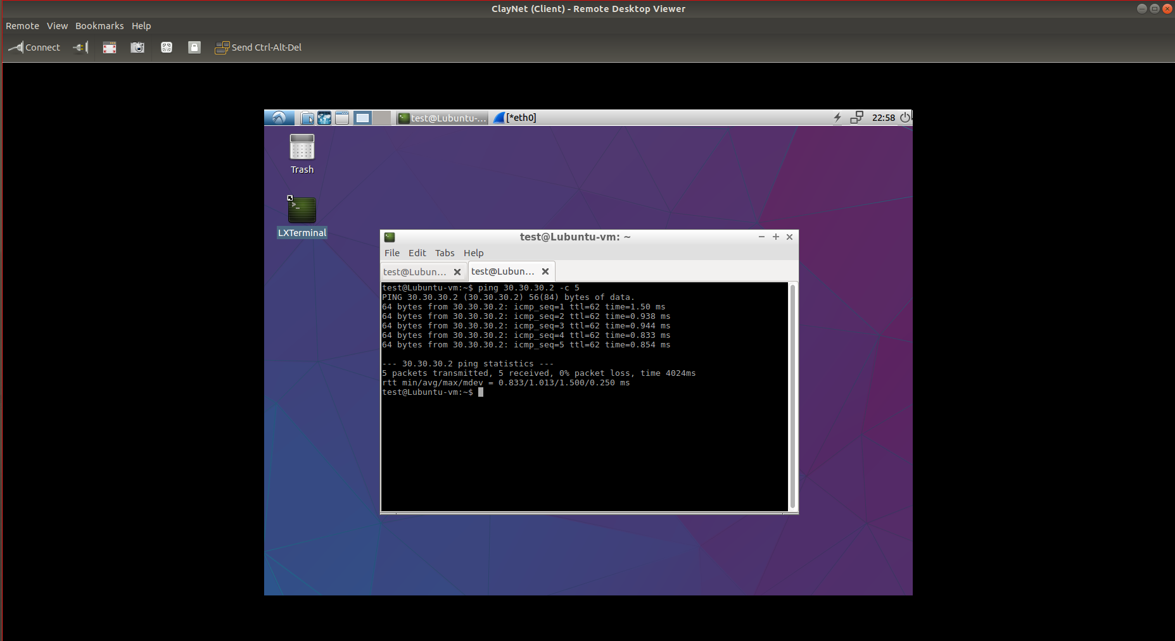
Fig : Terminal Ping Command for Task 1

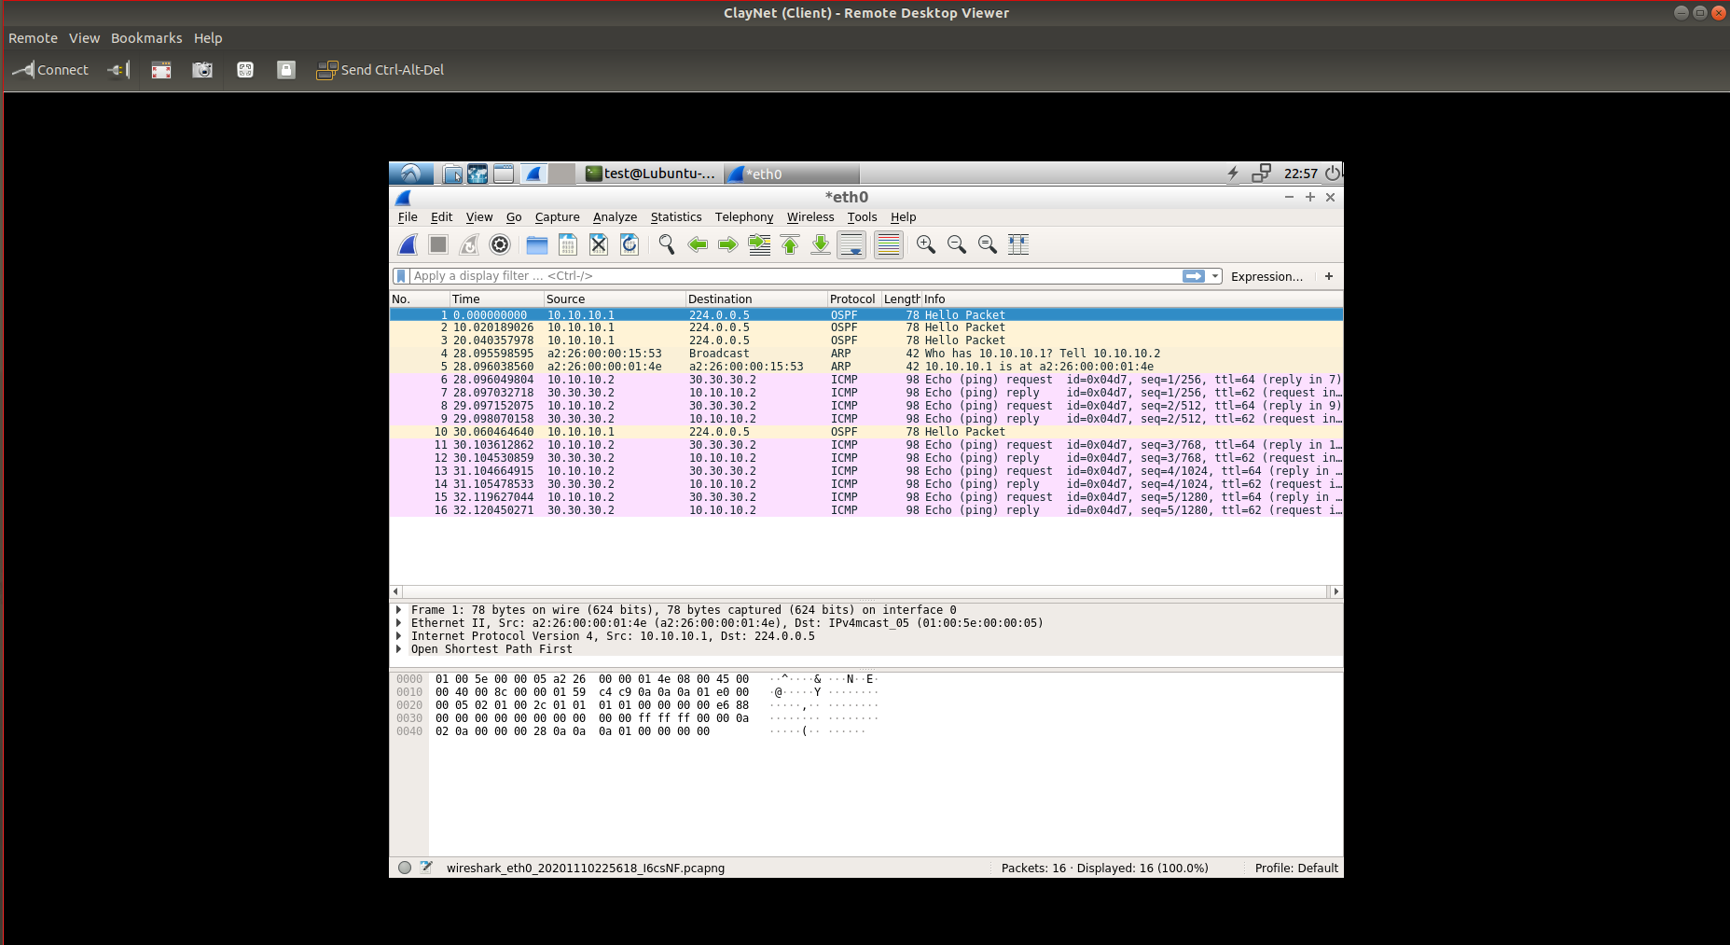

Fig : Wireshark Capture for Task 1

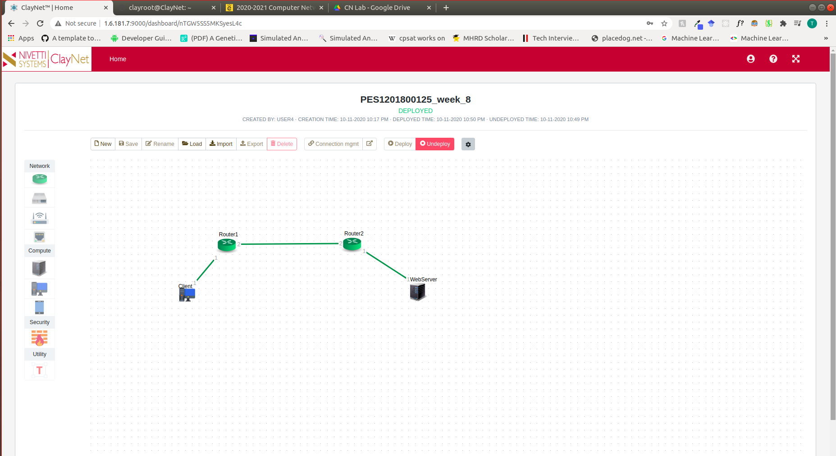
Fig : Topology for Task 1

